TECHNICAL PROJECT REPORT

Title of Invention / Project: TEMPERATURE AND HUMIDITY SENSOR

Team Members / Inventors:

|  |  |  |  |  |  |
| --- | --- | --- | --- | --- | --- |
| **S.No.** | **Name** | **Department** | **Designation** | **Mobile** | **E-Mail** |
| 1. | Lalu Kumar | ECE | Student | 7764819290 | lalukumar.rr14@gmail.com |
| 2. | Rohit Kumar Sharma | ECE | Student | 8219946872 | rohitsharmadec2017@gmail.com |
| 3. | Pushpinderjit Singh | ECE | Student | 9877170713 | pushpinder2273@gmail.com |
|  |  |  |  |  |  |
| 4. | Khushal Thakur | ECE | Mentor | 9646030764 | khushal.thakur@cumail.in |
| 5. | Anshul Sharma | ECE | Mentor | 9478697475 | anshulsharma.ece@cumail.in |
| 6. | Kiran Jot Singh | ECE | Mentor | 9463909689 | kiranjotsingh.ece@cumal.in |
| 7. | Divneet Singh Kapoor | ECE | Mentor | 9878422653 | divneet.ece@cumail.in |

Section – 1 (IPR Related)

Brief Abstract (500 words):

Problem your project is solving. It solves the problem of the costly, non durable temperature and humidity sensor by the new design of temperature and humidity sensor. And it is also portable that any body can carry it in their pocket and is also durable.

How are you solving that (solution)? It is very easy to use. It can be activated by only pressing a single switch and any body even inexperienced person can also use it easily without any pre instructions.

Additional modifications that can cater to improved solution. A human body temperature sensor can also be installed in it to sense temperature and humidity as well as body temperature.

Existing state-of-the-art and Drawbacks in existing state-of-the-art

|  |  |  |
| --- | --- | --- |
| **S. No.** | **Existing state of art** | **Drawbacks in existing state of art** |
| 1 | <https://www.youtube.com/watch?v=GVyabySFkFI> | The temperature and humidity sensor used in this is DHT 11 which is less accurate as compare to new DHT 22. |
| 2 |  |  |

Novel/Additional modifications that you can propose to improve upon drawbacks

* Can add a body temperature sensor in it to sense body temperature as well.
* Can add a feature of charging instead of using battery.

Advantages

* It is very portable, light weight and easy to carry anywhere.
* It is durable and cheaper as compare to other market sensors.

Block Diagram

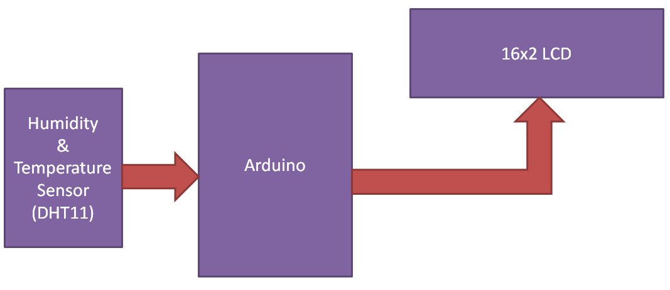

Section – 2 (Real Project)

Materials

Arduino uno

DHT sensor AM2302

Lcd 16×2

Plastic box

Switch on/off

10k resistance

9 volt battery

Small pcb

Wiring wires

Dual sided tape

Male/female wires

Glue gun

Programming cable

Circuit Diagram

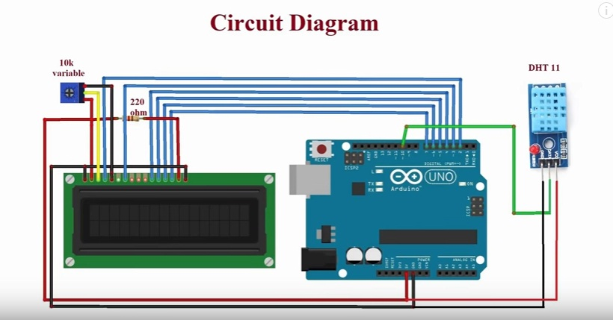

Steps of Circuit Completion

(*Bifurcate the circuit completion in steps, specify with photographs, leading to final project*)

**Step-1:-** First take a plastic box of any size and the use a 9 volt battery and a pcb. Place a 10k resistor to the pcb.

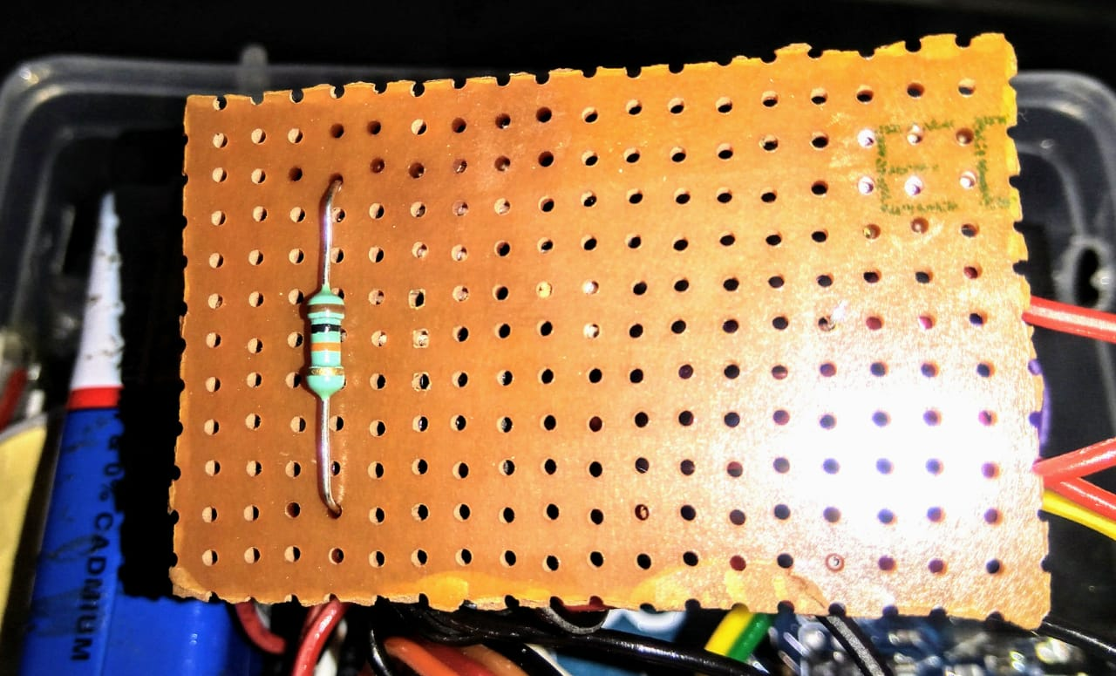

**Step-2:-** Now connect the +5 volt and ground of the arduino to the battery with an on/off switch.

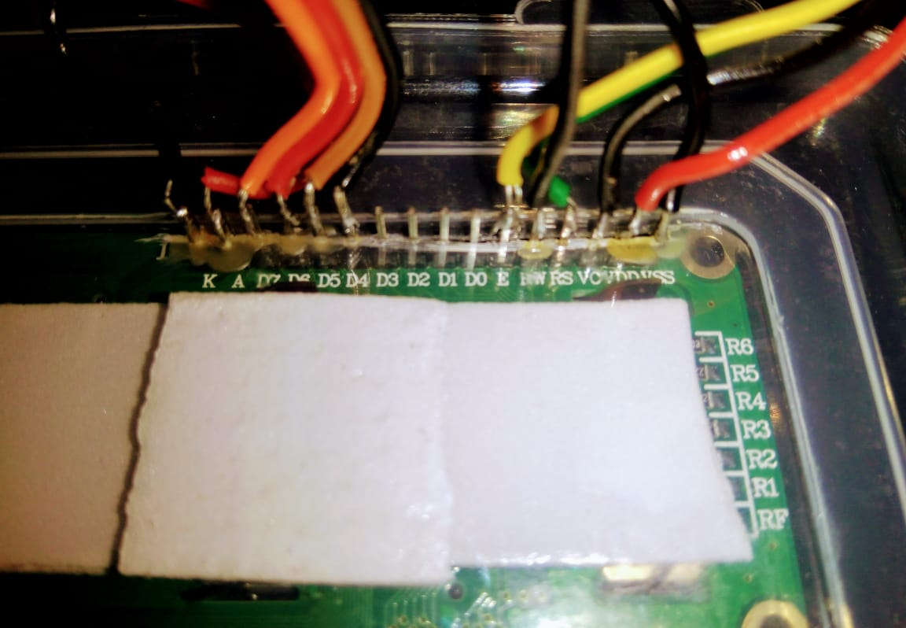

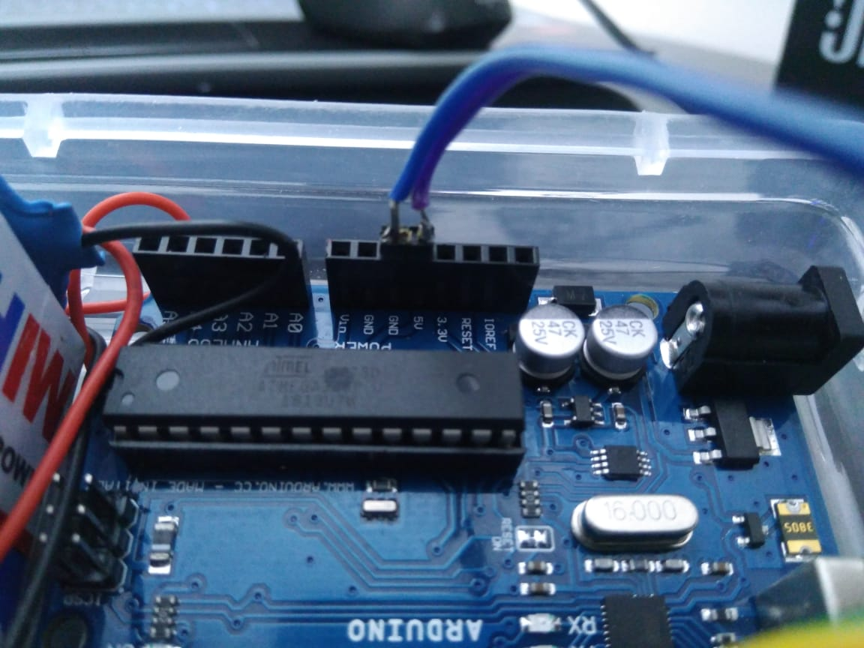

**Step-3:-**  Now place the temperature and humidity sensor out of the box to measure the temperature and humidity of that area. Connect pin 1 is connected to +5 volt, pin 2 is connected to Arduino pin 8(data pin), pin 4 is connected to ground.

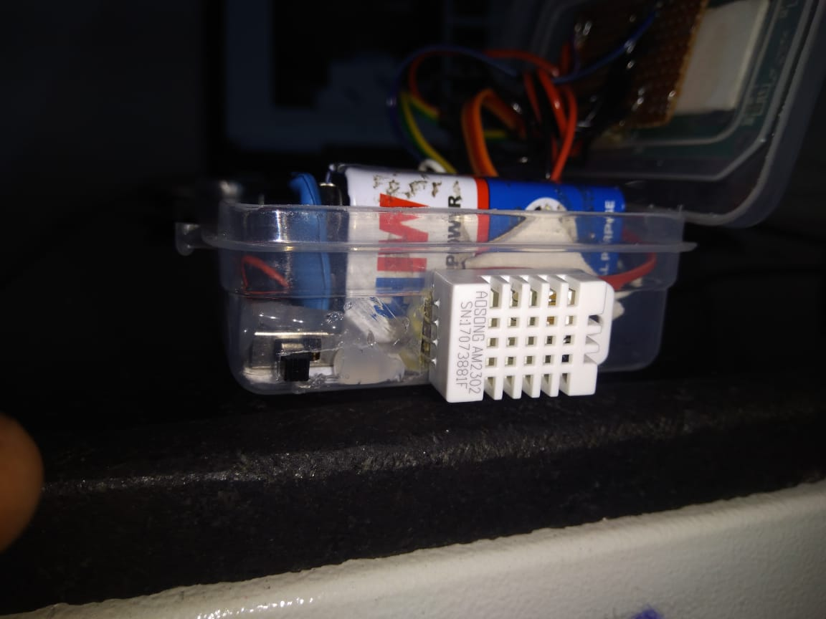

**Step-4:-**  Place an LCD on the top outside of the box to measure the temperature and humidity. Connect pin 1,5,16 to ground. pin 3 to 10k resistance and to +5 volt. LCD Pin 4 to pin 2 LCD pin 6 to pin 3 LCD pin 11,12,13,14 to pin 4,5,6,7.

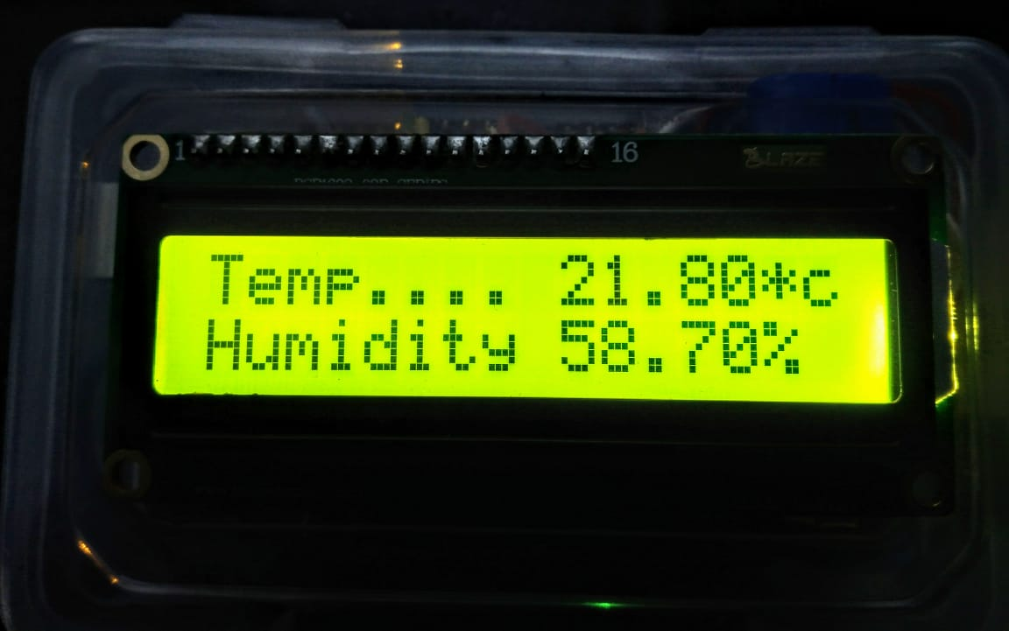



**Step-5:-** After placing and connecting all the components fix them all at their places via soldering and with the help of glue gun.

**Final Project:-** Temperature and humidity sensor.

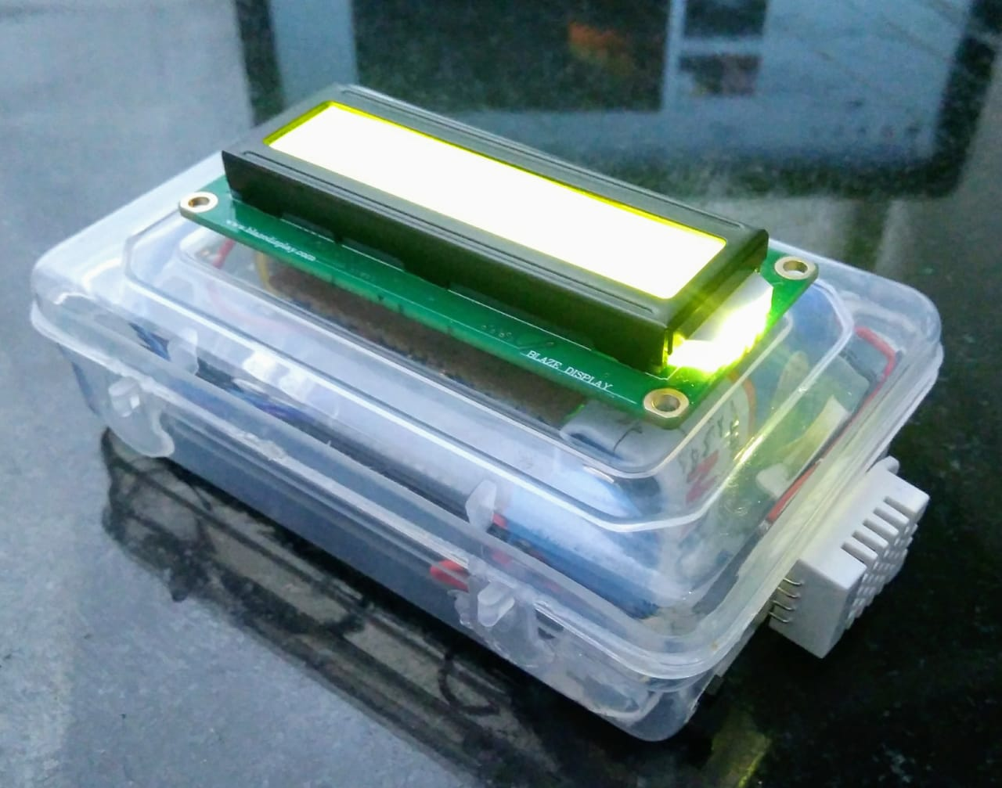

Program Code

<https://github.com/rohit-kumar-sharma/Temperature-and-humidity-sensor>